**Variables**

A variable is a name given to a memory location. It is the basic unit of storage in a program.

* The value stored in a variable can be changed during program execution.
* A variable is only a name given to a memory location, all the operations done on the variable effects that memory location.
* In C++, all the variables must be declared before use.

**How to declare variables?**

A typical variable declaration is of the form:

// Declaring a single variable

type variable_name;

// Declaring multiple variables:

type variable1_name, variable2_name, variable3_name;

A variable name can consist of alphabets (both upper and lower case), numbers and the underscore ‘_’ character. However, the name must not start with a number.

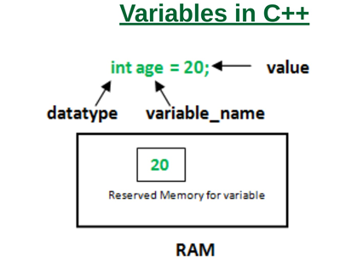

In the above diagram,

[*datatype*](https://www.geeksforgeeks.org/c-data-types/)*: Type of data that can be stored in this variable.*

***variable_name****: Name given to the variable.*

***value****: It is the initial value stored in the variable.*

**Examples**:

// Declaring float variable

float simpleInterest;

// Declaring integer variable

int time, speed;

// Declaring character variable

char var;

**Initialization of variables**

A first value may be specified in the definition of a variable. A variable with a declared first value is said to be an initialised variable.

Int val=102;

**Dynamic initialisation**

Initialisation of the variables at run time is referred to as dynamic initialization.

Example: Float avg=sum/count;